Project Design Phase
Solution Architecture

Date | 14 July 2026
Team ID
Project Name | Online Complaint Registration
Maximum Marks | 4 Marks

Solution Architecture:
The Online Complaint Registration System provides a digital platform that connects citizens with government departments for efficient complaint management. It replaces the manual complaint process with a secure, transparent, and user-friendly web application.

Goals of the Solution Architecture
1. Find the Best Technology Solution
- Digital complaint registration and tracking.
- Secure login and complaint management.
- Faster complaint resolution.
2. Describe the Software Structure
- Frontend: React.js for user interface.
- Backend: Node.js & Express.js for business logic.
- Database: MongoDB for storing user and complaint data.
- Authentication: JWT for secure access.
3. Define Features and Requirements
- User Registration & Login
- Complaint Submission
- Department Selection
- Complaint Tracking
- Admin Dashboard
- Status Updates & Notifications
4. Provide Solution Specifications
- Frontend: React.js, HTML, CSS, JavaScript
- Backend: Node.js, Express.js
- Database: MongoDB
- API: REST API
- Tools: VS Code, GitHub

Workflow
- User registers and logs in.
- User submits a complaint.
- Complaint is stored in MongoDB.
- Admin reviews and assigns the complaint.
- Status is updated.
- User tracks the complaint until resolution.
This solution architecture ensures secure, transparent, scalable, and efficient complaint management for both citizens and government departments.

Example - Solution Architecture Diagram:
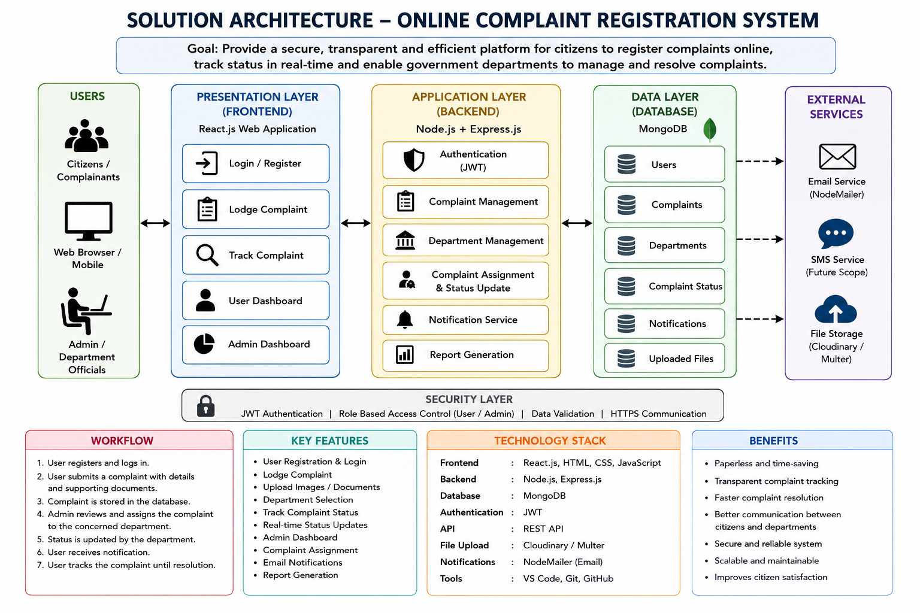

Figure 1: Architecture and data flow of the voice patient diary sample application

